**ASSIGNMENT 2 FRONT SHEET**

|  |  |  |  |
| --- | --- | --- | --- |
| **Qualification** | **TEC Level 5 HND Diploma in Computing** | | |
| **Unit number and title** | **Unit 43: Internet of Things** | | |
| **Submission date** | 11/04/2022 | **Date Received 1st submission** | 11/04/2022 |
| **Re-submission Date** |  | **Date Received 2nd submission** |  |
| **Student Name** | NGUYEN VAN HOA | **Student ID** | GCH200220 |
| **Class** | CCH1002 | **Assessor name** | LE ANH NGOC |
| **Student declaration**  I certify that the assignment submission is entirely my own work and I fully understand the consequences of plagiarism. I understand that making a false declaration is a form of malpractice. | | | |
|  |  | **Student’s signature** |  |

**Grading grid**

|  |  |  |  |  |  |  |
| --- | --- | --- | --- | --- | --- | --- |
| P5 | P6 | P7 | M5 | M6 | D3 | D4 |
|  |  |  |  |  |  |  |

|  |  |  |
| --- | --- | --- |
| **❒ Summative Feedback: ❒ Resubmission Feedback:** | | |
| **Grade:** | **Assessor Signature:** | **Date:** |
| **Internal Verifier’s Comments:** | | |
| **Signature & Date:** | | |

Contents

**I. Introduction 5**

**II. Employee an appropriate 5**

**1. Abstract 5**

**2. System requirement 5**

**2.1. Hard ware 5**

**2.2. Soft ware 9**

**3. Deployment 12**

**3. 1. Design 12**

**3.2. How the system work? 13**

**3.3. Test the software 16**

**3.4. Source code: 20**

**III. Evaluating End-User feedback from the IoT application. 27**

**1. User feedback 27**

**2. Evaluate from user feedback IoT application 30**

**IV. Evaluate end user feedback from your IoT application. 30**

**1. The product has met the basic requirements of the user. 30**

**2. Evaluate feasibility through the following factors: 31**

**3. Possibility of commercialization: 32**

**4. Improvements: Intuitive, customizable user interface/management portal: 32**

**Table of Figure:**

Figure 1: ESP8266 node MCU 6

Figure 2: RFID tags and Readers 7

Figure 3: 16x2 LDC display 7

Figure 4: EGG and SPO2 sensor 8

Figure 5: Breadboard 8

Figure 6: I2C Arduino 9

Figure 8 Web server 12

Figure 9 Design model 12

Figure 10: Device System 13

Figure 11: System work 13

Figure 12 Flowchart 14

Figure 13: Check in 17

Figure 14: Waiting the user action 17

Figure 15: User action 18

Figure 16: Send to server 18

# **Introduction**

Several other students' health status may not be suitable for health-demanding activities as well as long-term continuous activities due to a variety of objective and subjective factors. If that student continues to practice without being aware of his own health issues, he will suffer numerous negative consequences. Some unfortunate events occur with unfortunate outcomes.

To avoid those dangers, it is important to have solutions in place for students to know their health condition and avoid risks. Group 2 in the University of Greenwich Vietnam's GCH1002 class Research and give solutions to the problem. We came up with the idea for a project dubbed "Health-Check System for Education" - a system that allows pupils to rapidly determine if they are fit for exercise or not.

# **Employee an appropriate**

## **Abstract**

Regular physical exercise is extremely helpful to health, which is why this topic is taught in schools. However, due to their living or physical habits, kids currently confront a slew of issues when they engage in physical activity. This issue has occurred often and frequently results in unfavorable outcomes. To avoid this, the health - Check System for Education is meant to assess each student's health based on their heart rate and blood oxygen levels before beginning a physical course.

## **System requirement**

### **Hard ware**

1. **ESP8266 Node MCU**

The ESP8266 Wi-Fi enabled system on chip (SoC) module was invented by Espresso. It's most frequently utilized to build integrated Internet of Things (IoT) apps. It is powered by an 80 MHz Ten silica Extensa L106 32-bit RISC CPU. The system contains 96KB of data random-access memory, 64KB of command memory, and 64KB of startup memory. SPI can be used to access external flash storage.

This Wi-Fi module is a low-cost wireless transceiver that is ideal for IoT end-point applications. To connect with the ESP8266, the microcontroller needs utilize a set of AT commands (Wi-Fi module). The ESP8266-01 device is connected to the microcontroller through a UART with a preset Baud rate (Kolban, 2015).

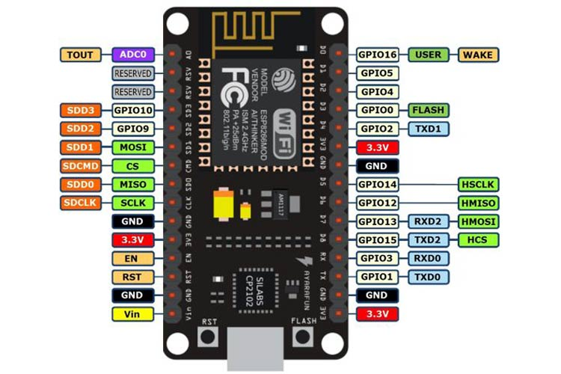

Figure : ESP8266 node MCU

1. **RFID tags and RFDI Reader**

RFID Tags and RFID Readers: RFID stands for radio frequency identification and refers to digital data stored in smart tags and obtained through radio waves by a reader. An RFID tag is composed of two parts. 1. A data transmission antenna; 2. An integrated circuit (IC) chip used to store data on the tag. RFID tags are attached to retail shop merchandise in order for the reader to track them. An antenna transmits energy to RFID tags, which activates the chip and sends a signal back to the antenna. Each chip includes memory banks that store information about the tagged item or the tag itself, depending on the memory bank selected (Amsle, 2022).

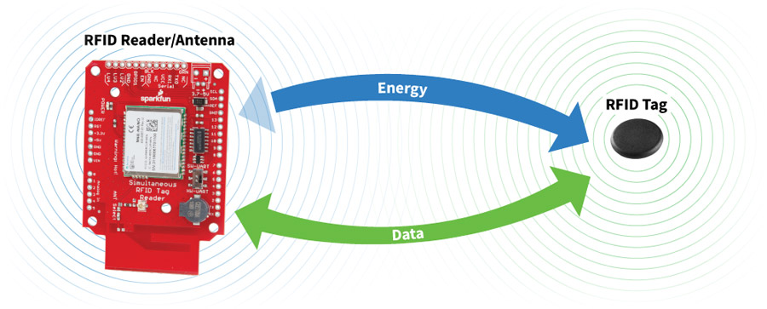

Figure : RFID tags and Readers

1. **16x2 LCD display**

A 16x4 LCD can display 16 characters per line and has four such lines. Each character is presented in a 5x7 pixel matrix on this LCD. This LCD contains two registers: Command and Data. The LCD on the HD44780 controller is standard (Sunrom, 2022). User can be checking the healthy status by them.

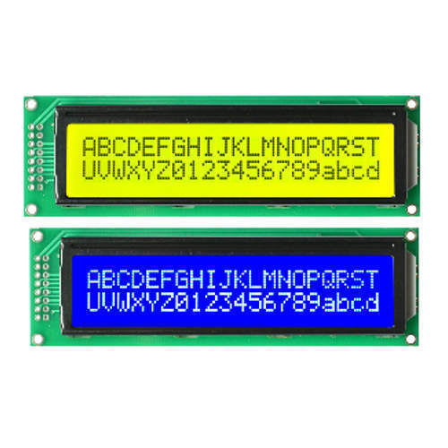

Figure : 16x2 LDC display

1. **ECG Sensor and SPO2 sensor**

The Spo2 sensor is an IoT medical gadget that measures blood oxygen saturation SpO2 and heart rate. The measurement of oxygen in the blood has a history of more than 150 years. As technology has advanced, this device has had the ability to evolve, enhance its accuracy, and reduce its size, allowing the general people access to a pulse oximeter (Rendall, 2021).

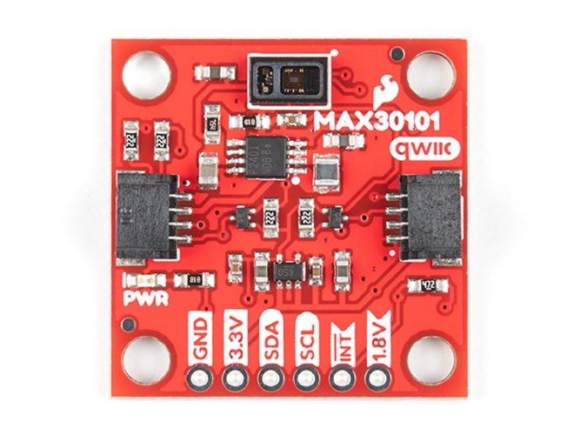

Figure : EGG and SPO2 sensor

1. **Breadboard**

A breadboard is a solderless device used to create temporary electrical prototypes and test circuit designs. Most electrical components in electronic circuits can be coupled by placing their leads or terminals into the holes and then connecting them with wires as needed.

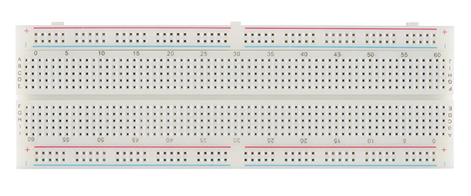

Figure : Breadboard

1. I2C Arduino

IIC is an abbreviation for "Inter Integrated Circuits." It is commonly referred to as I2C, I squared C, or even 2-wire interface protocol (TWI) in certain places, although it all implies the same thing. I2C is a synchronous communication protocol, which means that both devices sharing information must use the same clock signal (Electronicwings, 2022).

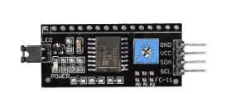

Figure : I2C Arduino

### **Software**

1. **Arduino**

The Arduino program is written in any language using a compiler that creates compatible code for the microcontroller's processors. The development must take place outside of the Arduino board, using an integrated development environment (IDE) that is unique to Arduino and operates on cross-platform operating systems like as Windows, Linux, and Macs. It mostly supports the Java programming language, as well as C and C++, with minor exceptions.

This IDE includes a software library with reusable input-output procedures to make coding easier, as well as easy editing features such as Cut and Paste, Search functionality, indenting, highlighting, brace matching, and a single click saving, compiling, and pushing the program to the Arduino processor. The generated code may be manually sent to the CPU using a USB connection and the copy command. Pro IDE provides a far more professional environment with Git integration (version control), auto-completion, new libraries, and many other current features (Educba, 2022).

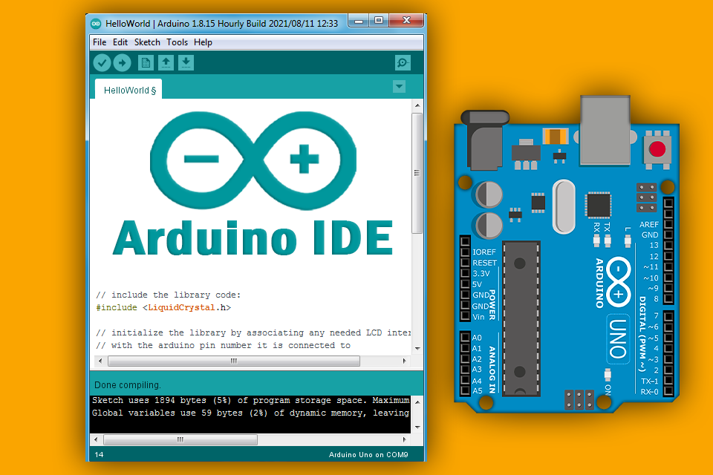

Figure : Arduino IDE

1. **Php**

PHP is now a Hypertext Preprocessor after being transformed from Personal Home Page. PHP, in a nutshell, is a multi-target (scripting language) computer language. PHP is commonly used on servers to design and run web applications. Thus, the PHP programming language may execute server functions to create HTML code on the client, such as datasheet templates gathered, database adjustments, and server administration files.



Figure : PHP

1. **MySql**

MySQL is an open source relational database management system (RDBMS) based on Structured Query Language that is supported by Oracle (SQL). MySQL operates on almost every platform, including Linux, UNIX, and Windows. Although it may be used for a variety of purposes, MySQL is most commonly linked with web applications and online publishing.

MySQL is a key component of the LAMP open source corporate stack. LAMP stands for Linux as an operating system, Apache as a web server, MySQL as a relational database management system, and PHP as an object-oriented programming language. (Perl or Python are sometimes used instead of PHP.

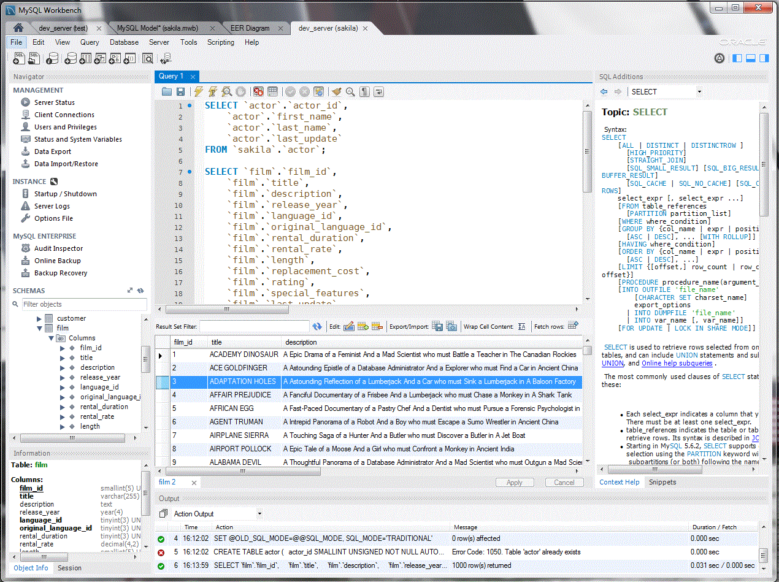

Figure : MySQL

1. **Web application**

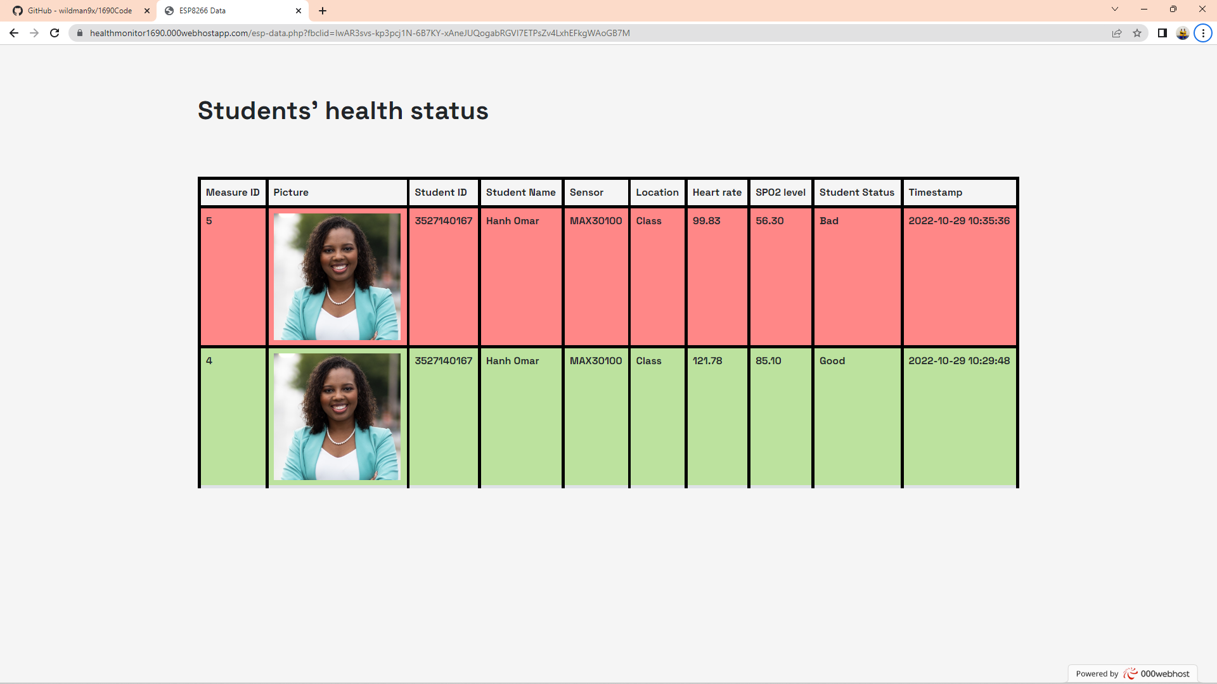

Figure Web server

The website will be pre-designed based on the school or educational institution's server, and stakeholders such as the health department, parents, and the school will be able to use it to look up and monitor the student health information.

## **Deployment**

### 1. Design

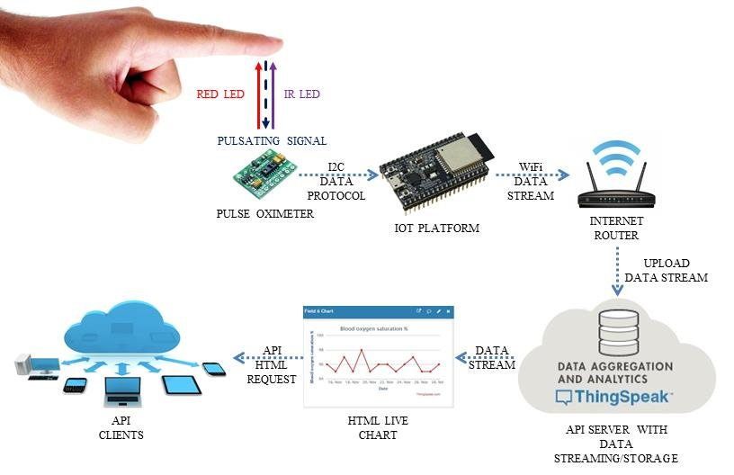

Figure Design model

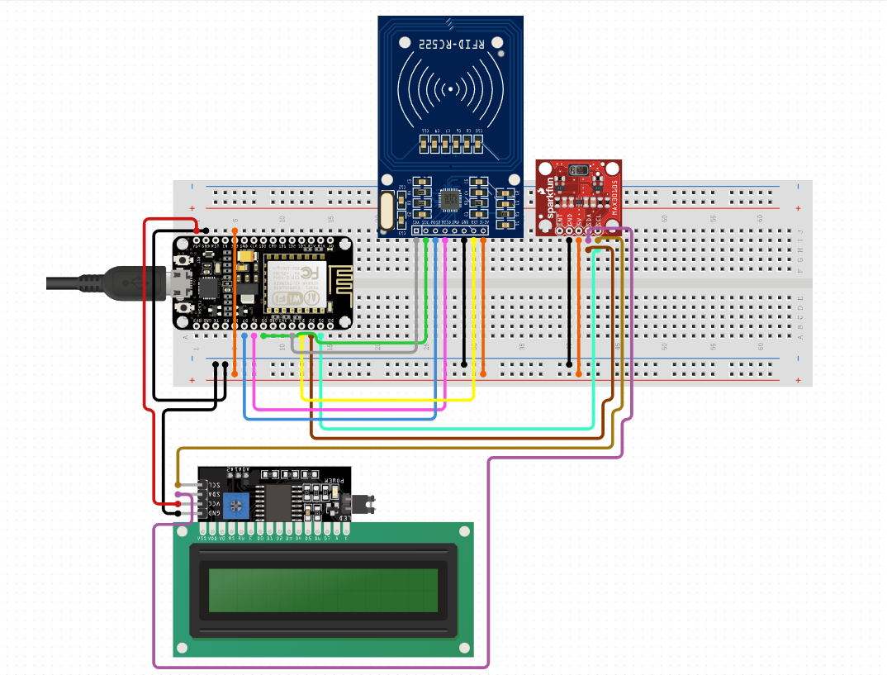

Figure : Device System

### **3.2. How the system work?**

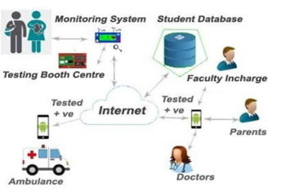

Figure : System work

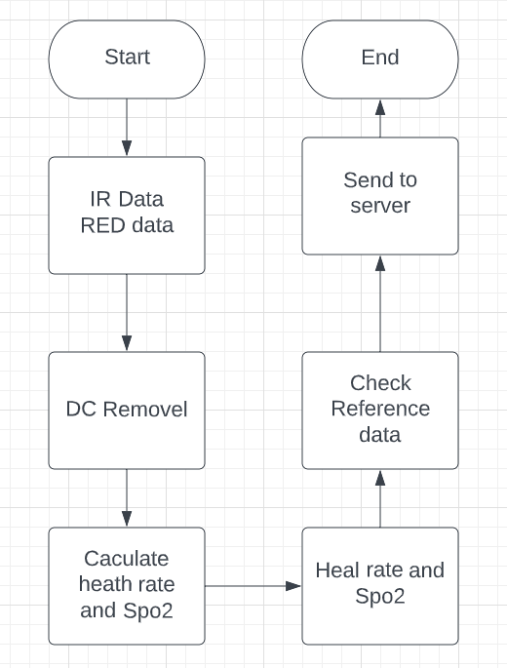

Figure Flowchart

As we do not require further registration, the suggested design may be executed using the following: the system employs RFID technology, which offers all relevant information about the student. Temperature readings, heart rate, and oxygen levels are all recorded by the health monitoring system. For communication between the two ends, the IOT integrated system is employed. If the student is determined to have poor health, the ends are responsible for medical care. Thus, using the suggested approach, student health may be readily monitored.

The following is a paradigm for IoT-based student healthcare monitoring and testing. The testing model is made up of three subsystems that work together to accomplish autonomous student healthcare management.

* + Student Database System
  + Health Monitoring System
  + IOT device.

1. **Student database System**

The student's information, as well as their personal data, is gathered and maintained in the school and college databases. Several databases from many schools and institutions have been collected and combined to form the consolidated student database. Details such as the student's name, date of birth, blood group, mobile phone, parents and caregiver number, address, and medical history are saved in the database for future reference.

The main health care departments are linked to the consolidated student databases. Their health may be monitored on a daily basis by health care agencies. If a student has a health concern, health care experts will visit the school or institution and take the required procedures to treat the students.

Thus, by keeping the information, the student's health may be prioritized. This database unit collaborates with the health monitoring system to measure temperature readings, pulse rate, heart rate, and oxygen saturation levels, among other things. These data are saved in RFID tags and sent to each student.

1. **Health monitoring System**

The health monitoring system is made up of an infrared temperature sensor, ECG sensors, and spo2 sensors. The IR SpO2 sensor detects each student's hands as they enter the classroom. The health monitoring system monitors for a normal hand sp02 range of 75 to 100 millimeters of mercury (mm Hg) and heart rate range of 60 to 100.

If the body spo2 and rises over the usual range, the system assumes the student has a bad and requests a medical examination. This information is also given to parents, caregivers, school or college administrators, and healthcare staff. ECG sensors are utilized to capture the student's heart rate measurements.

This ECG sensor will be activated if the pupil exhibits any indicators of being in poor health. The oxygen saturation level and pulse rate of the learner can then be determined using oximeters. These data are collected and saved on a daily basis. If any of the measured data exceeds the usual range, the pupil should be sent to a medical examination. These datasets are made available to the IoT system. To interact with other devices, IoT systems are integrated with various components.

(Leonardo Zumerkorn Pipek, Rafaela Farias Vidigal Nascimento, Milena Marques Pagliarelli Acencio & Lisete Ribeiro Teixeira , 2022)

1. **IoT device**

The IOT system is made up of a Node MCU, an RF Tag and Reader, an LCD Display, and a Wi-Fi module. The MCU is the system's heart, acting as a microcontroller device. Based on the command instructions, the instructions are delivered to the MCU controller, on which the microcontroller operates. The modem may be directly connected to a PC serial port or to any microcontroller equipped with the Wifi - module. The attendance recorder (RF tag and Reader) is linked to the Node MCU, which monitors the student's attendance at the entry. We employ RFID readers to scan the RFID tags that are issued to students as ID cards for the attendance system. RFID tags include all of the relevant information about the student. On the screen, the LCD module indicates the student's temperature range, heart rate, and oxygen levels. We're using a 20x2 LCD display here. The display and application will indicate the status of the student deviations from the typical range of values. The Wi-Fi module is utilized to link the networked IOT devices in order to facilitate network connectivity. The ESP8266 gadget is the primary Wi-Fi module. The student health monitoring data may be exchanged with primary health care facilities via the networking device to monitor the student's health. As a result, the suggested approach may be adopted in all schools and colleges to protect student health and provide a healthy atmosphere on school and college grounds.

### **3.3. Test the software**

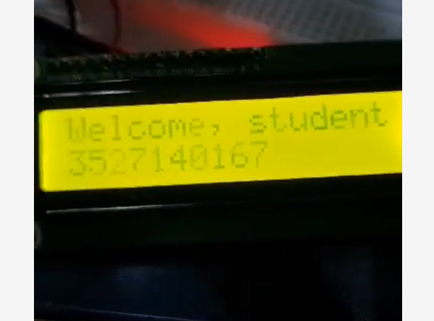

Figure : Check in

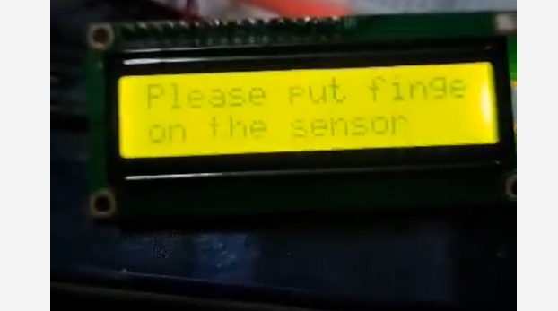

Figure : Waiting the user action

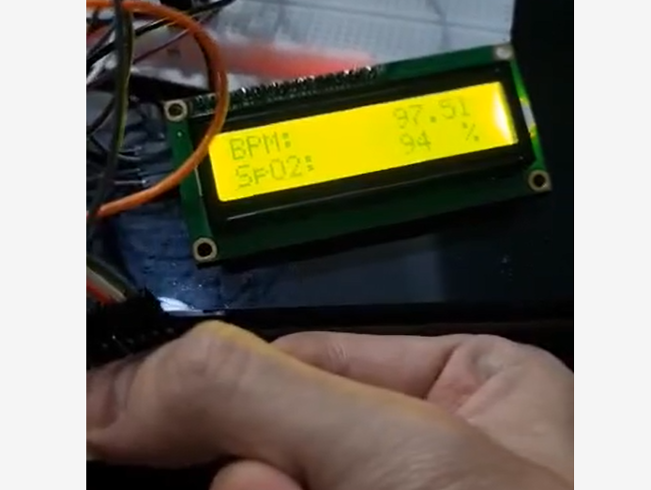

Figure : User action

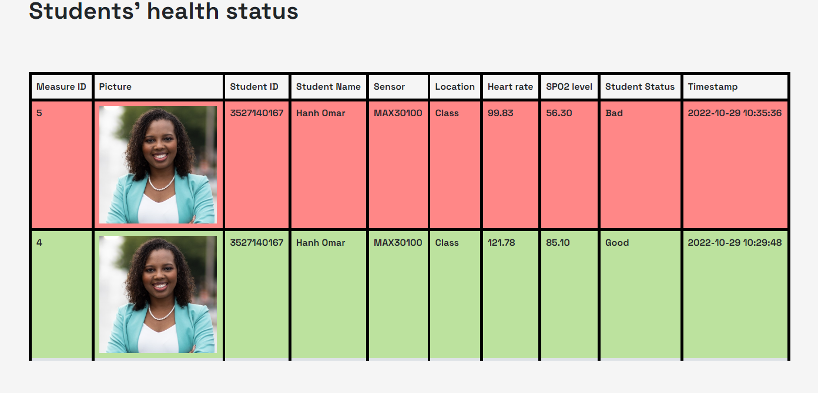

Figure : Send to server

|  |  |
| --- | --- |
| Critera | Sucess factors |
| Student status | * Sucess |
| Persional control | * Sucess check SPO2 and heart rate * Sucess check ID and information * Sucess view website * Sucess conenct to blink application |
| IoT system | * Sucess to conect to web server * Sucess to conect to blink * Sucess to conect to Lan * Sucess to conect sensor |

### **3.4. Source code:**

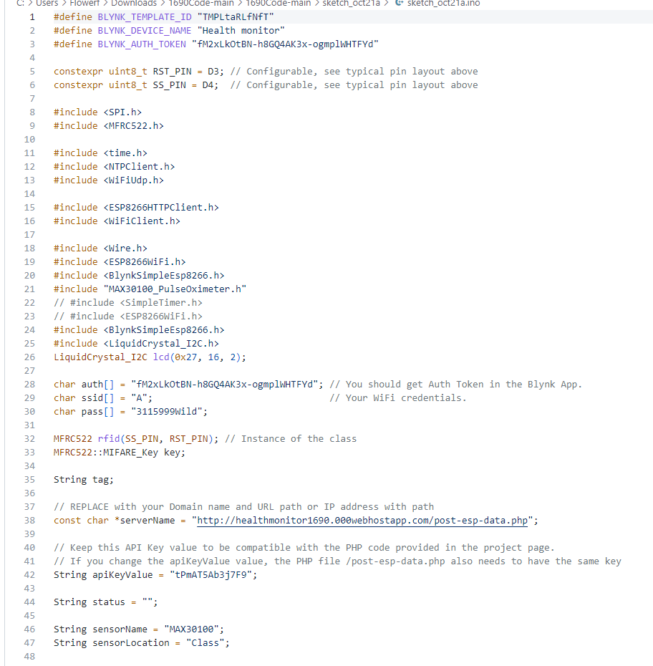

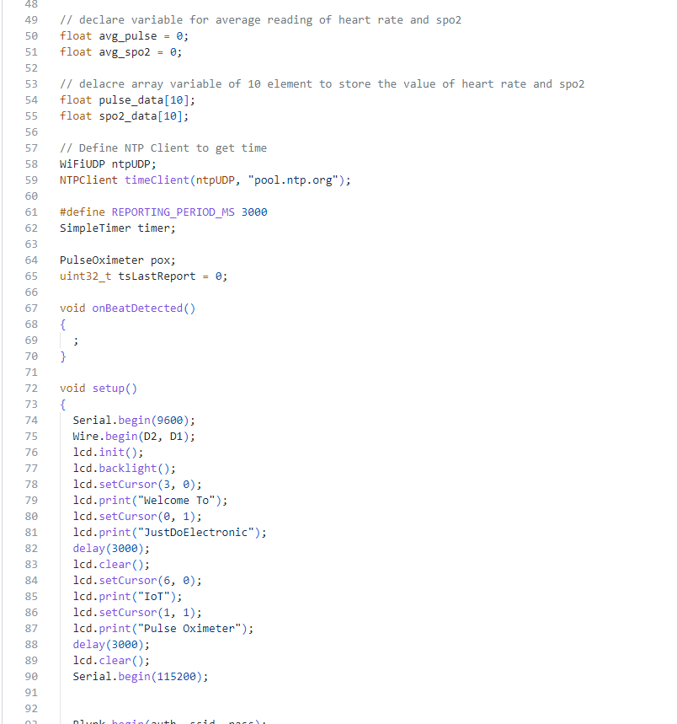

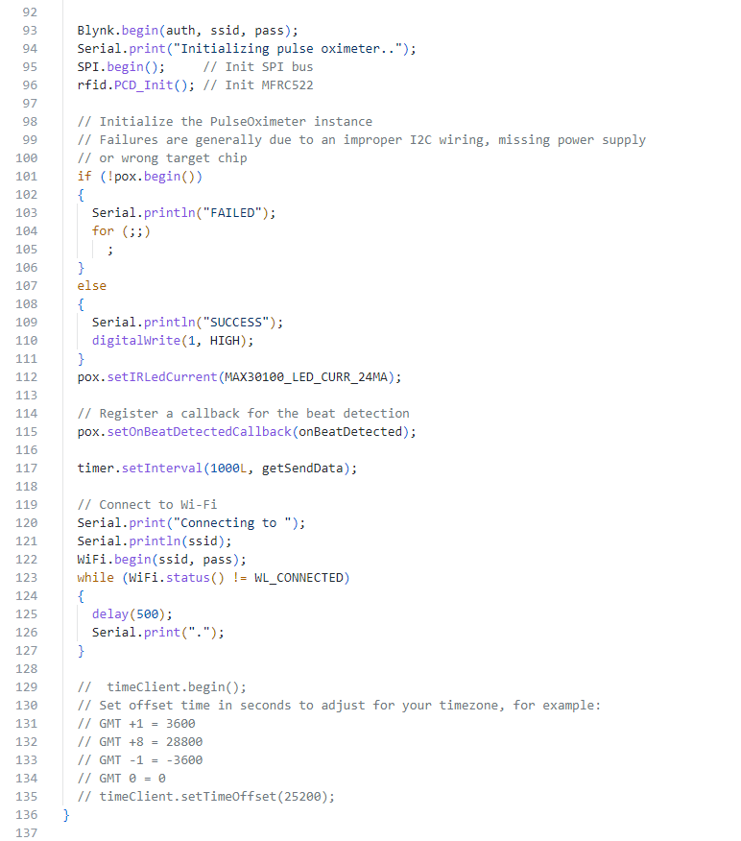

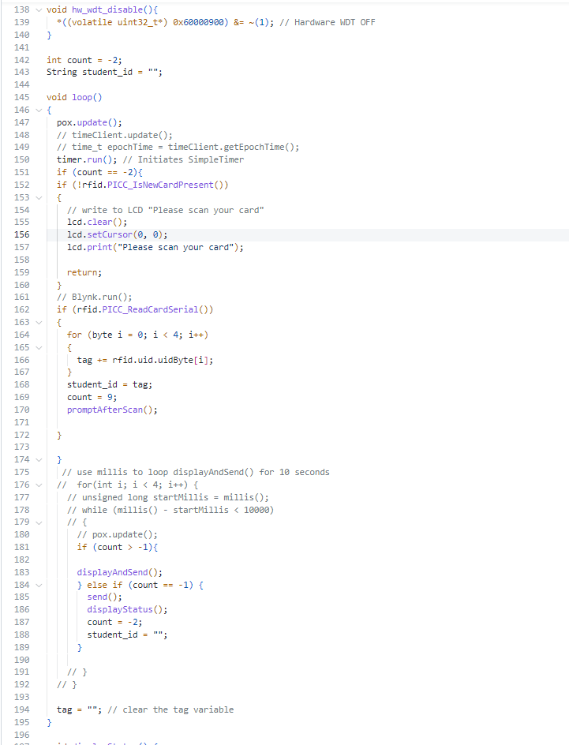

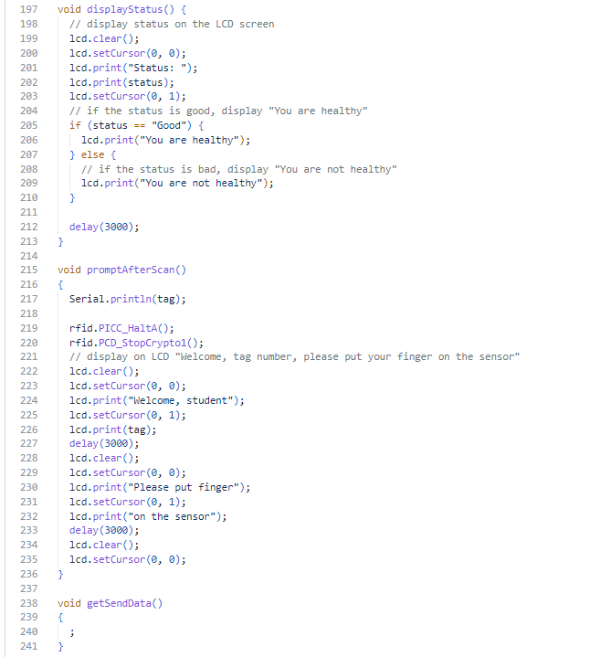

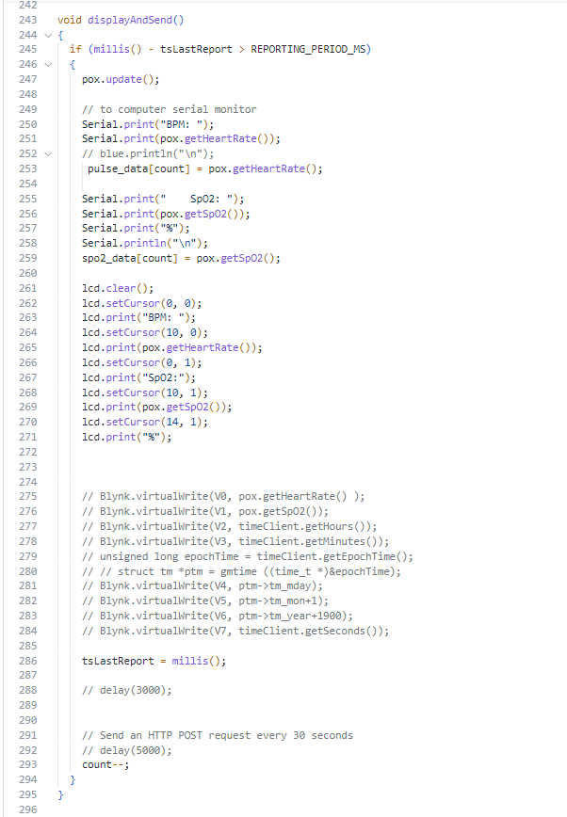

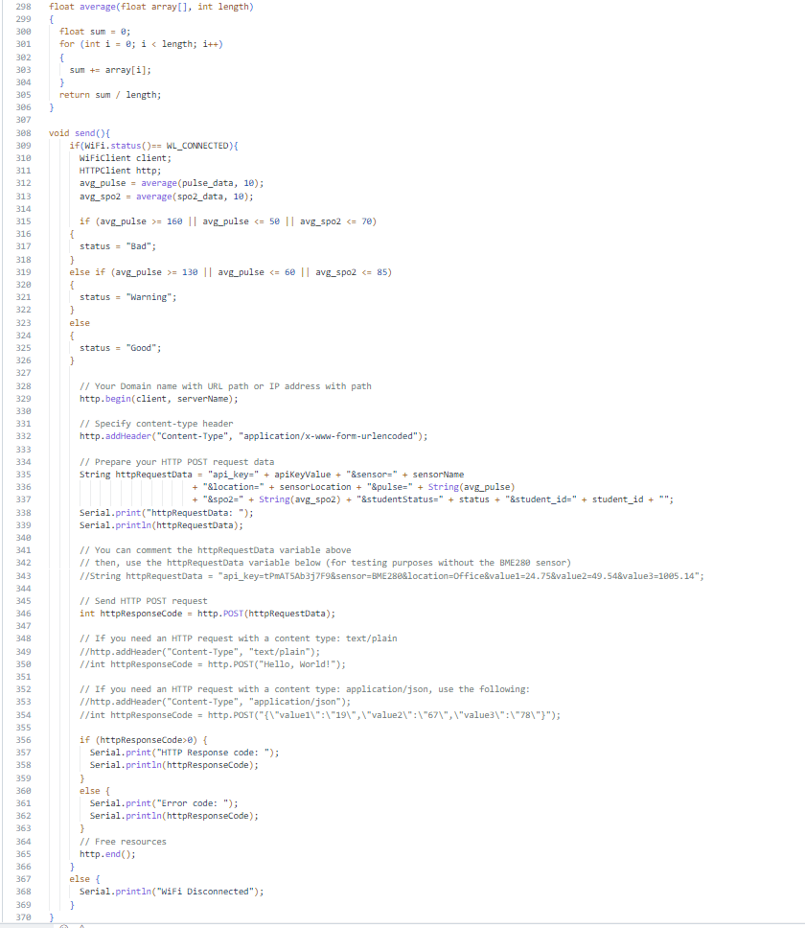

# **Evaluating End-User feedback from the IoT application.**

Any information gathered from users or customers regarding their experience with my product or service is referred to as user feedback. This user feedback can be either proactive (The manager’s product request them from users) or reactive (the users provide it to me unprompted).

Feedback may come from a variety of sources and in a variety of formats. Bug reports and help inquiries are examples of feedback.

Any thoughts about how to enhance the product Live chat, in-product surveys, email, phone, and more channels are available. After gathering input, multiple teams use it to enhance the user or customer experience.

## **User feedback**

Here are some results from surveys of over 100 random students who used the software:

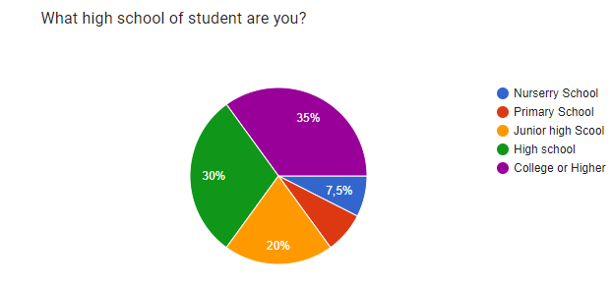

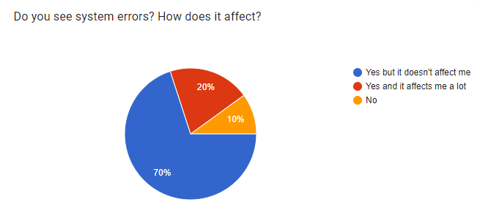

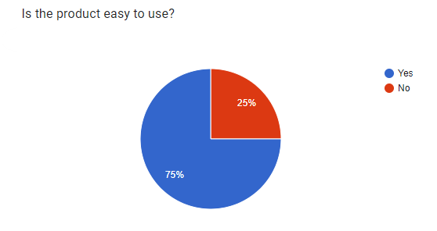

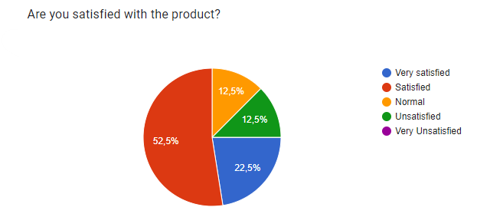

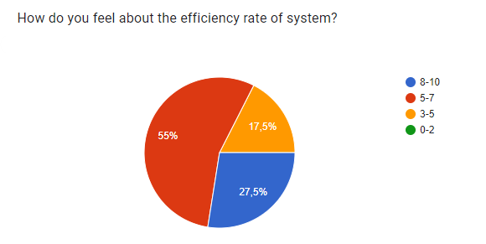

### **Evaluate from user feedback IoT application**

Based on the survey and customer comments, we want to develop and enhance the completion as well as solve the project's limitations in the future.

Because of the subjectivity of students, schools, and families. Students' ability to care for and monitor their peers' well-being is badly insufficient. The Student health check system, which includes a "website system, blink application, heart rate monitoring system, and spo2 concentration," acts as a computerized fog to assist monitor and discover dangers before they occur. In this paper, we created an IoT system based on the internet of healthcare things infrastructure model. Student parameters will be provided through the cloud system, indicating the pupils. Kids are experiencing health issues, and data is given to medical facilities, schools, and students' parents. This research has the potential to enhance medical management in educational settings.

The current system is dependent on the body sensors as well as the ambient circumstances in which the system sensors are present. It is a non-contact health monitoring device that requires the patient to be present within a few yards of the sensors. This model examined the student's indicators and recognized biological and behavioral changes using smart healthcare technology. The model that was created enhanced the accuracy of assessing a student's condition. Using machine learning and deep learning techniques, e-healthcare monitoring systems may be performed with more accuracy and in less time in the future.

# **IV. Evaluate end user feedback from your IoT application.**

To be able to meet user requirements, this IoT project must satisfy the following factors:

### **The product has met the basic requirements of the user.**

However, the author's team must consider the following difficulties for their product:

Product security is integrated: Security must be chosen and integrated into every aspect of the IoT operation. When it comes to network and device management, the most important requirement is that all data transmission - whether from base stations to management servers or from management servers to end applications - be encrypted using industry standard security protocols. If security is inadequate, there is a danger of system hacking.

Many vendors' device compatibility: Because the author's product is produced rapidly and without thorough planning, it will almost likely be incompatible with many new gadgets on the market today. The growing number of hardware providers has created a very complicated picture in the smart device ecosystem. Multi-vendor devices are essential to properly handle various difficulties in order for the IoT system to deliver the most value. As a result, the author must devise the best method possible using various gadgets.

## Evaluate feasibility through the following factors:

**Technical Capability**: The organization currently has sufficient technical resources to implement the project.

**Budget:** The organization currently has sufficient financial resources to implement the project.

|  |  |  |
| --- | --- | --- |
| Devices | Cost | Explain |
| Node MCU | 10$ | Main device |
| RFID Tags and RFID Reader | 4$ | Security checking |
| Wi-Fi ESP8266 module | 5$ | Support connecting to IOT system |
| 20x2 LCD display | 4$ | Display heals status of students |
| ECG sensor and SPO2 Sensor | 4$ | While entering the classroom, note each student's temperature. Health monitoring |
| I2C Arduino | 3$ | Support connecting |

**Legality:** Since the project has just been completed, legal issues have not been implemented yet. Therefore, it is necessary to conduct product authentication at the nearest agencies.

**Risks**: Risks related to the implementation of this project may be hardware and software malfunctions, but the organization will fix it as soon as possible.

**Time:** The project will be completed within a reasonable timeline.

|  |  |  |
| --- | --- | --- |
| Project Phases | Time | Detail |
| Build operational models | Took 1 days | Drawing models online  Insert the code into the model  Test the model |
| Buy tools | Took 2 days | Buy components for installation |
| Installing the product | Took 4 days | Hardware installation and software installation |
| Test run the product | Took 1 days |  |

## **Possibility of commercialization:**

The author wants to develop the device into wireless and remote control goods in the future. Remote control technology applications have advanced significantly in the 4.0 era, providing customers with more pleasant and convenient living experiences. As a result, investment in this market will reward the author.

## **Improvements: Intuitive, customizable user interface/management portal:**

Even if a REST API is accessible for integration and management from the user's preferred interface, the network management solution must have its own clean, consistent, and intuitive user interface. On the user interface, all tasks such as device management, data monitoring, network status information, and backend integration should be simply accessible and navigable. Similarly, incoming communications must be updated in real time, and the ability to filter messages and export data must be available.

# References

Amsle, S., 2022. *RFID (radio frequency identification).* [Online]   
Available at: https://www.techtarget.com/iotagenda/definition/RFID-radio-frequency-identification#:~:text=The%20RFID%20reader%20is%20a,in%20the%20RFID%20tag%20itself.

Educba, 2022. *Introduction to Arduino Application.* [Online]   
Available at: https://www.educba.com/arduino-application/

Electronicwings, 2022. *Arduino I2C.* [Online]   
Available at: https://www.electronicwings.com/arduino/arduino-i2c#:~:text=I2C%20(Inter%2DIntegrated%20Circuit),only%20two%20wires%20for%20communication.

Kolban, 2015. *ESP8266 Community Forum.* [Online]   
Available at: https://www.esp8266.com/viewtopic.php?p=25341

Leonardo Zumerkorn Pipek, Rafaela Farias Vidigal Nascimento, Milena Marques Pagliarelli Acencio & Lisete Ribeiro Teixeira , 2022. *Comparison of SpO2 and heart rate values on Apple Watch and conventional commercial oximeters devices in patients with lung disease.* [Online]   
Available at: https://www.nature.com/articles/s41598-021-98453-3

Rendall, J., 2021. *FDA clears ScanWatch, a hybrid smartwatch that monitors ECG and blood oxygen levels.* [Online]   
Available at: https://www.cnet.com/health/medical/fda-clears-scanwatch-a-hybrid-smartwatch-that-monitors-ecg-and-blood-oxygen-levels/

Sunrom, 2022. *20x4 LCD Black on Yellow/Green.* [Online]   
Available at: https://www.sunrom.com/p/20x4-lcd-black-on-yellowgreen